Hash Table

What is a Hash Table?
# Source: AI Source: Provided by: [Data Path: Persons Table -> ID Column: 1, Name_En Column: Motasem Essam] -> From: [Chatgpt (GPT‑5 Mini)] on [12/10/2025]
- A hash table is a data structure that stores key-value pairs.
- It uses a hash function to compute an index into an array of buckets, from which the desired value can be found quickly.
- Used for fast data retrieval, implementing dictionaries, caches, and sets.

Key Characteristics
# Source: AI Source: Provided by: [Data Path: Persons Table -> ID Column: 1, Name_En Column: Motasem Essam] -> From: [Chatgpt (GPT‑5 Mini)] on [12/10/2025]
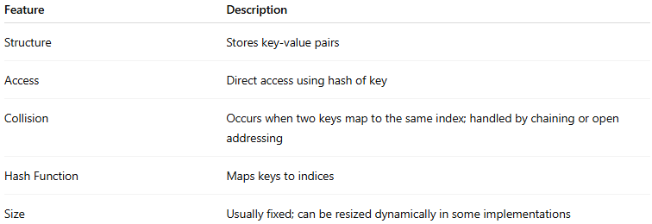
Feature | Description
Structure | Stores key-value pairs
Access | Direct access using hash of key
Collision | Occurs when two keys map to the same index; handled by chaining or open addressing
Hash Function | Maps keys to indices
Size | Usually fixed; can be resized dynamically in some implementations

Types of Hash Tables
# Source: AI Source: Provided by: [Data Path: Persons Table -> ID Column: 1, Name_En Column: Motasem Essam] -> From: [Chatgpt (GPT‑5 Mini)] on [12/10/2025]
- Chaining
  - Each bucket contains a linked list of elements that hash to the same index.
  - Handles collisions by storing multiple elements at the same index.
  - Example:
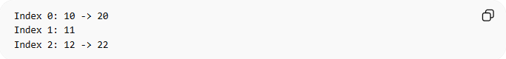
Index 0: 10 -> 20
Index 1: 11
Index 2: 12 -> 22
- Open Addressing
  - All elements stored in the array itself.
  - Collisions are resolved by probing (linear, quadratic, or double hashing).
  - Example (linear probing):
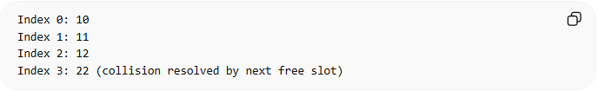
Index 0: 10
Index 1: 11
Index 2: 12
Index 3: 22 (collision resolved by next free slot)
- Dynamic / Resizable Hash Table
  - Can grow or shrink depending on load factor.
  - Uses rehashing to maintain performance.
- Perfect Hashing
  - No collisions; every key maps to a unique index.
  - Useful when all keys are known in advance.

Example of Hash Table
# Source: AI Source: Provided by: [Data Path: Persons Table -> ID Column: 1, Name_En Column: Motasem Essam] -> From: [Chatgpt (GPT‑5 Mini)] on [12/10/2025]
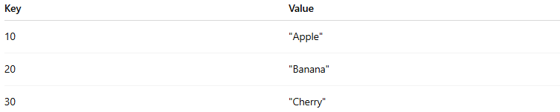
Key | Value
10 | "Apple"
20 | "Banana"
30 | "Cherry"
Collision example with chaining:
Index 0: (10, "Apple") -> (20, "Banana")
Index 1: (30, "Cherry")

Common Operations on Hash Table

1. Insertion (Adding a Key-Value Pair)
# Source: AI Source: Provided by: [Data Path: Persons Table -> ID Column: 1, Name_En Column: Motasem Essam] -> From: [Chatgpt (GPT‑5 Mini)] on [12/10/2025]
Definition:
- Add a key-value pair to the hash table.
- Compute index using hash function.
- If collision occurs, resolve using chaining or open addressing.
Example:
Insert (40, "Date") into hash table:
Index = hash(40) = 0
Collision with 10 and 20 → add to chain: 10 -> 20 -> 40

Insertion Time Complexity:
- Time Complexity:
  - Average: O(1)
  - Worst-case: O(n) (all keys collide)
- Reason: Hashing allows direct access; collisions may require traversal.

2. Deletion (Removing a Key-Value Pair)
# Source: AI Source: Provided by: [Data Path: Persons Table -> ID Column: 1, Name_En Column: Motasem Essam] -> From: [Chatgpt (GPT‑5 Mini)] on [12/10/2025]
Definition:
- Remove a key-value pair from the hash table.
- Locate key using hash function; remove element from bucket or probing sequence.
Example:
Delete key 20:
Index 0 chain: 10 -> 20 -> 40
After deletion: 10 -> 40
Deletion Time Complexity:
- Time Complexity:
  - Average: O(1)
  - Worst-case: O(n)
- Reason: Direct access via hash, but may need to search bucket if collisions exist.

3. Searching (Finding a Key/Value)
# Source: AI Source: Provided by: [Data Path: Persons Table -> ID Column: 1, Name_En Column: Motasem Essam] -> From: [Chatgpt (GPT‑5 Mini)] on [12/10/2025]
Definition:
- Find the value associated with a key.
- Compute hash, then check the bucket or probing sequence for the key.
Example:
Search key 40 → value = "Date"
Searching Time Complexity:
- Time Complexity:
  - Average: O(1)
  - Worst-case: O(n)
- Reason: Direct index access, but collisions may require traversal.

4. Traversal (Visiting All Key-Value Pairs)
# Source: AI Source: Provided by: [Data Path: Persons Table -> ID Column: 1, Name_En Column: Motasem Essam] -> From: [Chatgpt (GPT‑5 Mini)] on [12/10/2025]
Definition:
- Visit each key-value pair in the hash table.
- Useful for printing all entries, computing totals, or modifying values.
Example:
Index 0: 10 -> 40
Index 1: 30
Traversal prints: 10, 40, 30
Traversal Time Complexity:
- Time Complexity: O(n)
- Reason: Every element must be visited once.

Summary of Hash Table Operations
# Source: AI Source: Provided by: [Data Path: Persons Table -> ID Column: 1, Name_En Column: Motasem Essam] -> From: [Chatgpt (GPT‑5 Mini)] on [12/10/2025]
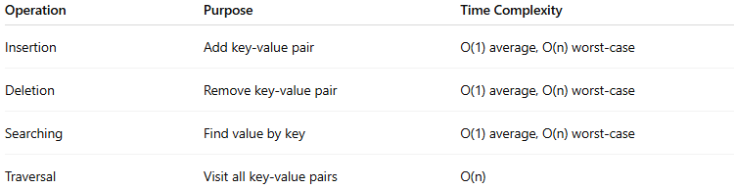
Operation | Purpose | Time Complexity
Insertion | Add key-value pair | O(1) average, O(n) worst-case
Deletion | Remove key-value pair | O(1) average, O(n) worst-case
Searching | Find value by key | O(1) average, O(n) worst-case
Traversal | Visit all key-value pairs | O(n)

Real-World Examples
# Source: AI Source: Provided by: [Data Path: Persons Table -> ID Column: 1, Name_En Column: Motasem Essam] -> From: [Chatgpt (GPT‑5 Mini)] on [12/10/2025]
- Dictionary lookup (word → definition)
- Caching frequently accessed data
- Database indexing
- Storing unique IDs and counters

Advantages
# Source: AI Source: Provided by: [Data Path: Persons Table -> ID Column: 1, Name_En Column: Motasem Essam] -> From: [Chatgpt (GPT‑5 Mini)] on [12/10/2025]
- Fast insertion, deletion, and search on average
- Efficient for key-value lookups
- Simple to implement with arrays and hash functions

Disadvantages
# Source: AI Source: Provided by: [Data Path: Persons Table -> ID Column: 1, Name_En Column: Motasem Essam] -> From: [Chatgpt (GPT‑5 Mini)] on [12/10/2025]
- Poor performance if many collisions occur
- Requires good hash function design
- Memory may be wasted for empty buckets or resizing

